Setup of mysql
- Install mysql.
- Run the SQL script in mysqlData
- In netbeans route to Resources> “<default Packages>” >application.properties
- Change spring.datasource.username = “this is where you add your username of mysql server”
- Change Spring.datasource.password = “ this is where you add your password for your mysql server”
- Test if it works open prg371Application.java.
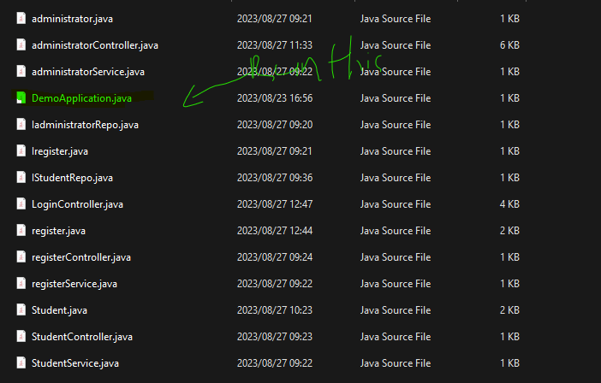

If you want to close the connection, click there to close the connection.

Routing info
I used postman to check if the connection work
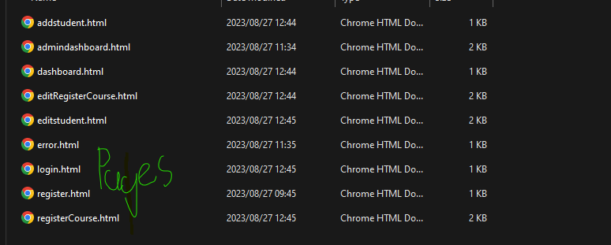

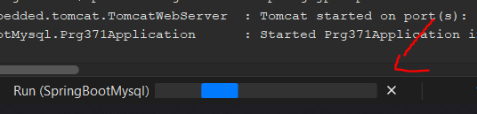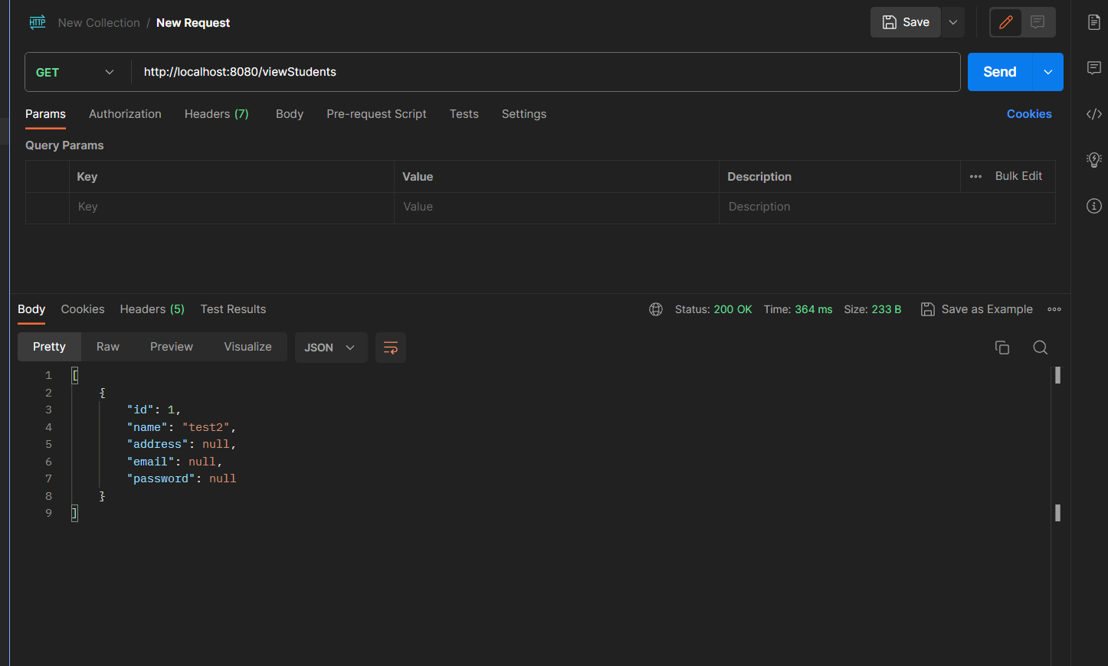

Returns all the info in students still need to implement for the other two tables.
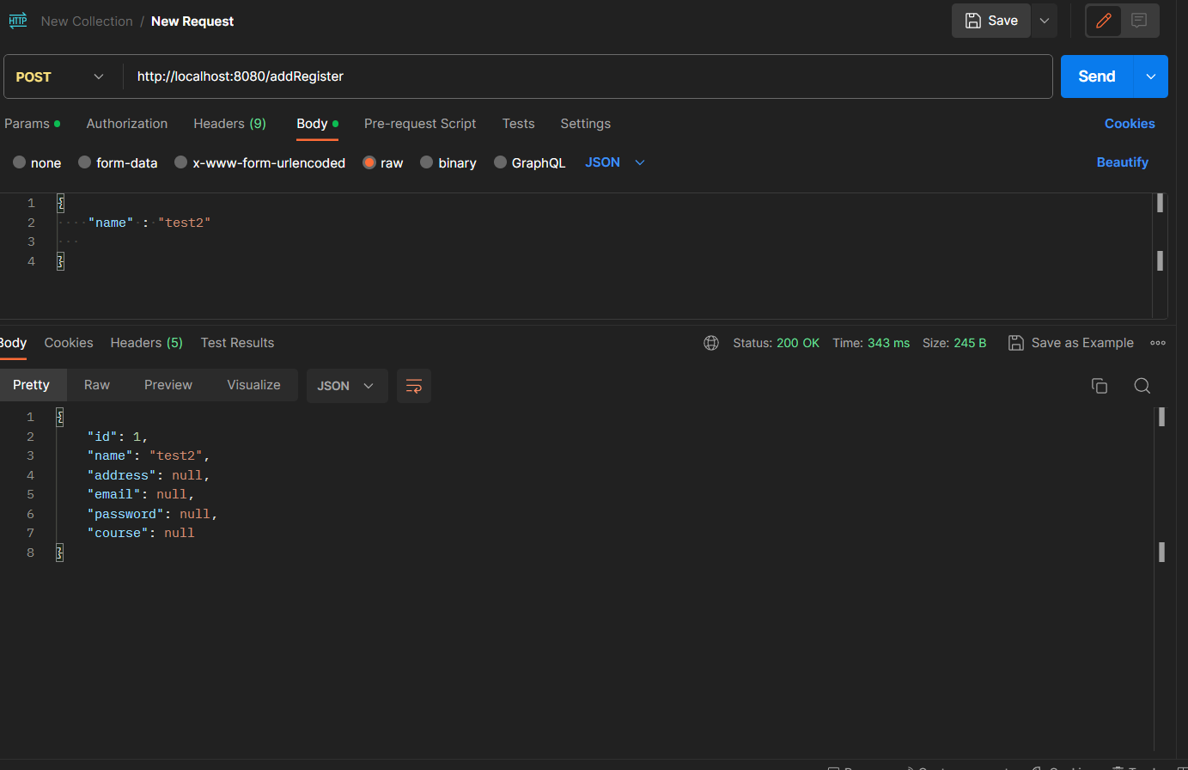
All the tables insert has been implemented the names in the java is the same as the var name in entity so for example in administrator Admin_name will be name.
